1. Given that an EMPLOYEE class contains following members: Employee Number, Employee Name, Basic, DA, IT, Net Salary. Member functions: to read the data, to calculate Net Salary and to print data members. Write a C++ program to read the data of N employees and compute Net Salary of each employee. (Dearness Allowance (DA) = 52% of Basic and Income Tax (IT) = 30% of the gross salary. Net Salary = Basic + DA - IT).

- prepare default constructor, parameterized constructor

- array of objects

- add two employees salary

#include <iostream>

#include <string>

using namespace std;

class employee

{

private:

string name;

int number;

float basicSalary,netSalary;

public:

employee():name("NULL"),number(0),basicSalary(0.0){}

employee(string name,int no,float bsly):name(name),number(no),basicSalary(bsly){}

void calculateNetSalary();

void displayDetails();

int addSalary(employee e);

};

void employee::calculateNetSalary()

{

float dearnessAllowance,grossSalary,incomeTax;//no need to display these, these are needed only to calculate,so not declaring in private but here

dearnessAllowance=(basicSalary\*52)/100;

grossSalary=basicSalary+dearnessAllowance;

incomeTax=(grossSalary\*30)/100;

netSalary=basicSalary+dearnessAllowance-incomeTax;

}

int employee::addSalary(employee e)

{

int total=0;

total=netSalary+e.netSalary;

return total;

}

void employee::displayDetails()

{

cout<<"Employee Name : "<<name<<endl;

cout<<"Employee Number : "<<number<<endl;

cout<<"Basic Salary : "<<basicSalary<<endl;

cout<<"Net Salary : "<<netSalary<<endl<<endl;

}

int main()

{

employee e1("Deven",125678,100000.0);

employee e2("Dev",234567,200000.0);

e1.calculateNetSalary();

e1.displayDetails();

e2.calculateNetSalary();

e2.displayDetails();

int total=e1.addSalary(e2);

cout<<"Total Salary = "<<total<<endl;

return 0;

}

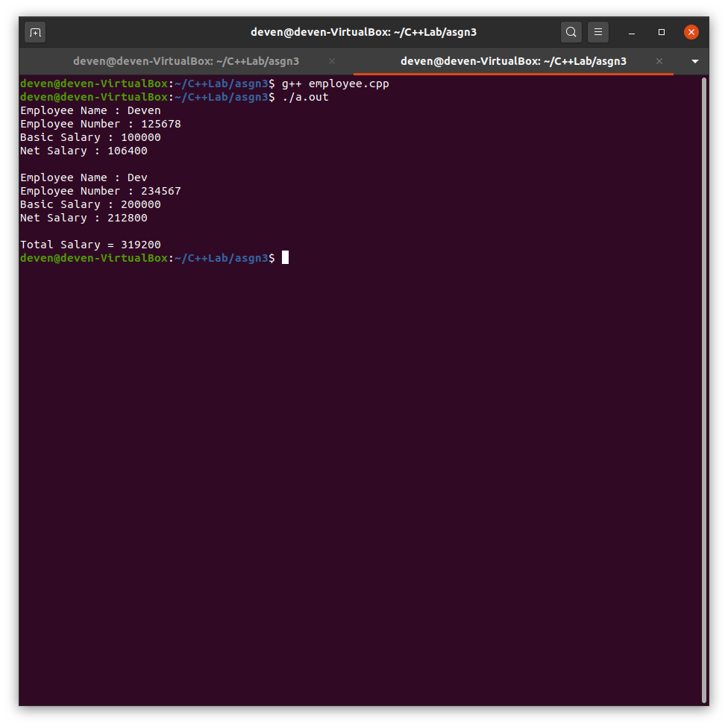

2. inline function to print sqrt of a number [separate program]

#include <iostream>

#include <cmath>

using namespace std;

inline float sqroot(float n)

{

return sqrt(n);

}

int main()

{

float n;

cout<<"Enter a number : ";

cin>>n;

cout<<"The square root of "<<n<<" is "<<sqroot(n)<<endl;

return 0;

}

